**Date of Issue: Monday 25th March 2019**



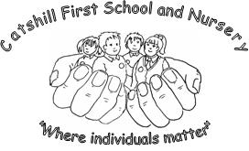

**YEAR 1 VISIT TO BODENHAM ABORETUM**

**WEDNESDAY 1st MAY 2019**

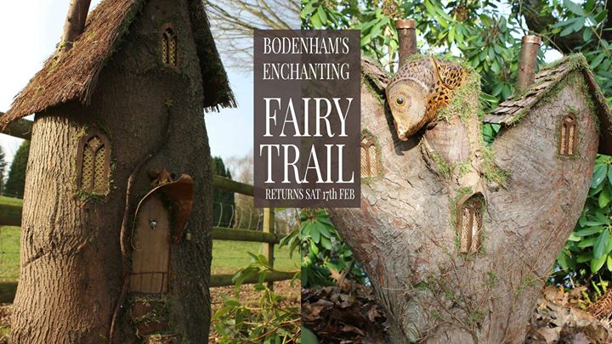

Dear Parents/Carers of Year 1 Children

Next half term, **Year 1’s** topic is Enchanted Forest. We are very excited to start our learning with an educational visit to **Bodenham Arboretum** on **Wednesday 1st May**. The coach will leave school at 9.15am and return by 3pm in time for normal home time arrangements.

All children will be provided with a packed lunch under the Universal Free School Meals scheme. This will contain a sandwich, a cookie and a drink. You may wish to send in some additional food and drinks as the packed lunch is fairly basic. If you prefer to provide your own packed lunch (no nut containing ingredients or glass bottles please) we ask that you indicate this on the reply slip below.

They will also need warm outdoor clothes and shoes/wellies as we will spend the day outside and participate in Forest School activities. School uniform jumpers must be worn.

The cost of the trip is £10.20 per child. We are asking for voluntary contributions for this amount and in order for the trip to go ahead we will need to have enough voluntary contributions to cover the cost. If we cannot cover the cost then the trip will be cancelled.

Please sign the consent form below and return, together with a note of your payment reference from Payments4Schools by **Monday 8th April 2019**. We are no longer able to accept cash payments; if you require any help with the online payment system, please see a member of the office staff who will be able to assist you.

**Mrs C Mercer Mrs L Barker**

**Mrs T Wiley Mrs Z Partridge**

**____________________________________________________________________________________________**

**Catshill First School and Nursery – Visit Bodenham Arboretum**

* **I agree / do not agree** that my **child** _______________________________ in class _________ may take part in the visit to Bodenham Arboretum on Wednesday 1st May 2019.

I confirm that I have made payment via Payment4Schools. My reference number is ……………………………………

I **do not** want a packed lunch provided by school and will provide my own.

I understand that the County Council accepts no liability other than in respect of enforceable third party claims against members of its staff.

I agree to medical and dental treatment being given to my son/daughter if required, including the administration of a general anaesthetic and to surgical operations in the case of emergency, in accordance with the recommendations of a qualified medical practitioner.

PARENT/CARER’S SIGNATURE DATE